**ASSIGNMENT-1 (DC CIRCUIT)**

1) DEFINE FOLLOWING TERMS:

a) Node

b) branch

c) loop

d) mesh

e) active element

f) passive element

g) junction point

2) Explain concept of open circuit in series.

3) Explain concept of open circuit in parallel.

4) Explain concept of short circuit in series.

5) Explain concept of short circuit in parallel.

6) Explain kirchhoff’s current law with explanation.

7) Explain kirchhoff’s voltage law with explanation

8) Explain Mesh Analysis with example.

9) Explain Nodal Analysis with example.

10) Explain the delta to star transformation.

11) DEFINE FOLLOWING TERMS

a) linear network

b) non-linear network

c) active network

d) passive network

e) bilateral network

12) Explain current source.

13) Explain voltage source.

14) Write the statement of superposition theorem.

15) Write the statement of norton’s theorem

16) Write the statement of thevenin theorem.

17) Write limitation of superposition theorem.

18) Explain the procedure superposition theorem with suitable example.

19) Explain the procedure thevenin’s theorem with suitable example.

20) Explain the procedure norton’s theorem with suitable example.

21) Explain the star to delta transformation.

22) Find I in the circuit shown in figure 1.

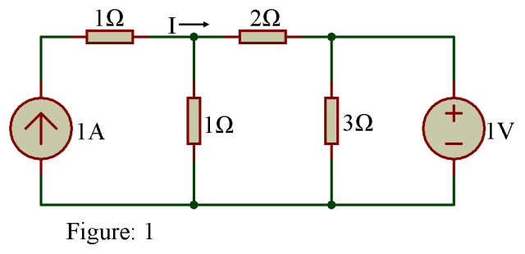

23)Find Current flowing through 1Ω resistor by using superposition theorem.

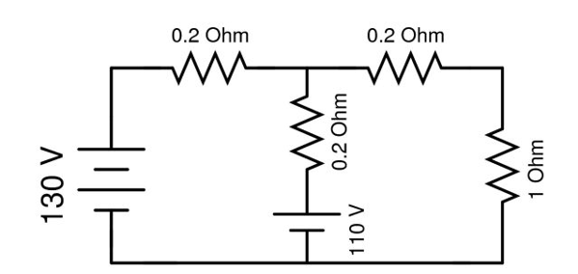

**24) Find current flowing through 5 Ω using Norton theorem.**

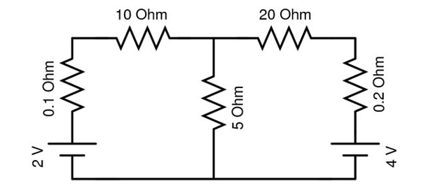

25) Determine current through 1 Ω resistor using superposition theorem.

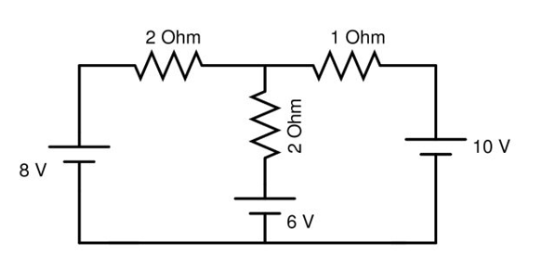

**26) Find current through 20 Ω resistor.**

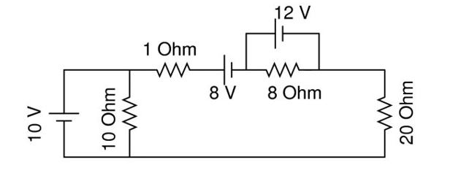

**27) Calculate the current that flows in the 1 Ω resistor in the following circuit.**

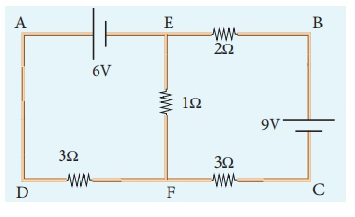

28) Calculate the Thevenin resistance across the terminal AB for the following circuit.

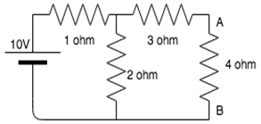

29) Calculate Vth for the given circuit.



30) What is the current in the circuit?

